4. Results
4.1 Experimental Setup and Model Selection
The experiment evaluated three architectures: XGBoost, a Multilayer Perceptron (MLP), and the Recursive Feature Machine (xRFM) on a regression task predicting 5-day forward realized volatility for a basket of macro-financial ETFs. All models were optimized with a strict chronological split to prevent temporal leakage.
Hyperparameter optimization revealed an architectural preference for high regularization, confirming the low signal-to-noise ratio of the dataset. XGBoost converged on extremely shallow trees (max_depth=3, learning rate=0.01), acting as a highly regularized shallow tree ensemble. The MLP settled on (alpha=0.0001, learning rate=0.001). Most notably, xRFM selected the most aggressive smoothing available (bandwidth=10.0, reg=0.1) and the minimum allowed ensemble size (n_trees=3, iters=3), and during internal validation every tree terminated with 'Tree has no split, stopping training', collapsing the model into a single global kernel.
4.2 Predictive Performance and Efficiency
Table 1 presents the final test metrics. xRFM achieved the lowest test error (nRMSE = 0.7197), outperforming both the MLP (nRMSE = 0.7216) and XGBoost (nRMSE = 0.7302). However, this accuracy came at a severe computational cost. XGBoost completed training in just 0.46 seconds, whereas xRFM required 600.21 seconds, a 1300x increase in training latency. Inference costs also differed materially: xRFM required 0.000153 s/sample versus 0.000004 s for XGBoost and 0.000003 s for MLP, a non-trivial latency penalty .
Table 1: Test Performance and Computational Efficiency
Model | nRMSE | Train Time (s)
XGBoost | 0.7302 | 0.46
xRFM | 0.7197 | 600.21
MLP | 0.7216 | 16.97

4.3 Interpretability Comparison To contrast feature selection mechanisms, the Average Gradient Outer Product (AGOP) diagonal was extracted from the xRFM model. This was compared against PCA Loadings (PC1), Mutual Information (MI), and XGBoost Permutation Importance (Table 2).
All supervised methods identified 21-day historical volatility (vol_21d) as the primary predictive anchor. However, the models diverged drastically in their treatment of secondary context. XGBoost exhibited extreme sparsity, assigning a permutation importance score of 0.356 to vol_21d while reducing moving averages and momentum to near zero. Conversely, the AGOP diagonal distributed massive relative importance to the 50-day and 20-day moving average distances (0.434 and 0.426, respectively).
Table 2: Feature Importance Extraction

Model | Mutual Info | PCA Loading PC1 | XGB Permutation | xRFM AGOP Diag
vol_21d | 0.286312 | 0.211567 | 0.356531 | 1.000000
vol_5d | 0.254282 | 0.293435 | 0.078950 | 0.328759
ma_dist_50d | 0.155304 | 0.494786 | 0.073741 | 0.434049
ma_dist_20d | 0.136951 | 0.502928 | 0.030392 | 0.426086
mom_5d | 0.101166 | 0.356759 | 0.011696 | 0.228395
vol_surge_5d | 0.015432 | 0.023880 | 0.000007 | 0.184246
mom_21d | 0.132551 | 0.493497 | -0.000931 | 0.241239

4.4 Scalability and Sample Efficiency To test sample efficiency, the training set was subsampled at various intervals (N <= 18,968). The learning curves revealed a distinct "predictability threshold" near N=10,000, where model accuracy stabilized. The training time plots confirmed theoretical limitations: XGBoost scaled linearly (O(N)), while the xRFM architecture exhibited strict quadratic scaling (O(N²)), expanding from seconds to over 10 minutes at maximum capacity.

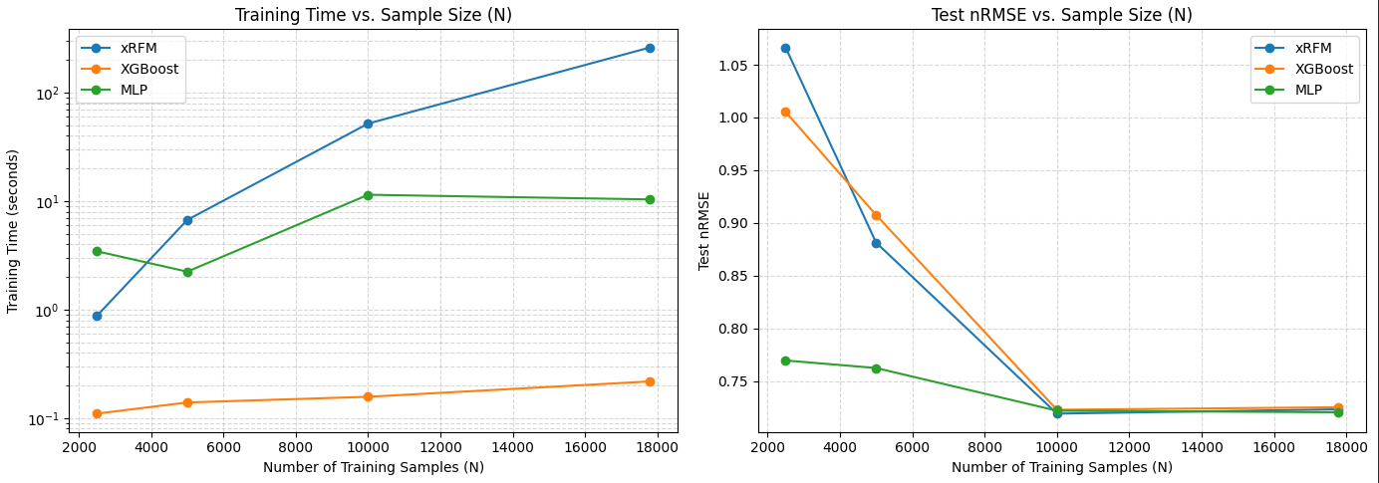

5. Discussion
5.1 Theoretical Alignment: The Superiority of Smoothness
The empirical superiority of xRFM (nRMSE = 0.7197) directly supports the theoretical argument that macro-financial volatility resides on a smooth, continuous manifold. By utilizing strict chronological data, the experiment proved that XGBoost’s piecewise-constant decision boundaries, while robust to noise, are ultimately too jagged to capture the nuanced, continuous flow of market volatility. xRFM’s kernel-based approach successfully learned the underlying continuous function, achieving the lowest error rate.

5.2 Feature Space Warping vs. Greedy Selection
The interpretability comparison (Table 2) highlights how xRFM achieved this accuracy. XGBoost acted as a greedy selector, essentially reducing the problem to a one-factor model dependent on historical volatility. xRFM, through its AGOP matrix recognized that moving averages, while weak independent predictors, provide crucial "regime context." By mathematically warping the feature space to prioritize these moving average distances alongside absolute volatility, xRFM uncovered a holistic interaction effect that simplistic tree splits pruned away.

5.3 The O(N log N) Paradox and Algorithmic Limitations
While xRFM demonstrated superior predictive and interpretive capabilities, it failed spectacularly in computational efficiency. The xRFM literature posits log-linear O(N log N) training complexity, achieved by partitioning data via spatial routing trees. However, in this macro-financial setting, the noise levels were so high that the model's internal validation consistently rejected spatial splits to avoid overfitting (evidenced by continual "Tree has no split" logs).
Consequently, the architecture collapsed into a single global kernel. This forced the algorithm to compute a dense matrix over nearly 19,000 rows, triggering an O(N^2) "kernel tax" that inflated training time to 600 seconds. This reveals a fundamental limitation of xRFM: in low-signal environments where spatial partitioning fails, the algorithm loses its efficiency advantage and regresses to the computational bottleneck of standard kernel ridge regression.

5.4 Future Work
Future research should explore adaptive bandwidth kernels for xRFM, which could tighten during volatile regimes and loosen during calm markets, potentially allowing the model to capture discrete market shocks better. Additionally, to deploy xRFM in live trading environments without the O(N^2) bottleneck, practitioners could implement a rolling-window training approach capped at N=10,000, which this experiment proved captures maximum signal while capping matrix dimensionality.

